UNIT 1 PEOPLE
OUTLINE

1 Language Development
1.1 Personal pronouns and possessive adjectives
1.2 The verb be
1.3 Nouns and verbs
1.4 Singular and plural forms
2 Vocabulary
2.1 Family
2.2 Jobs
2.3 Countries and nationalities
3 Critical Thinking
3.1 Ideas Maps
An ideas map helps you think about the topic and organize information about it. It also helps you to remember key information and vocabulary.
3.2 Family Tree
A family tree shows the relationship in a family.
4 Input
4.1 Listening
4.1.1 Understanding key vocabulary
4.1.2 Listening for main ideas
4.1.3 Listening for detail
4.2 Reading
4.2.1 Previewing
4.2.2 Understanding key vocabulary
4.2.3 Skimming
4.2.4 Scanning to find information
5 Output
5.1 Speaking: Tell us about the person in your ideas map.
5.2 Academic writing skills:
Punctuation: the full stop
5.3 Writing task:
Write about somebody in your family

EXERCISES

- Listen to the words. Then write them in the correct column.
(MP3 A1U1-1)

student teacher father sister doctor
mother brother journalist designer parents

Job | Family

- Circle the correct phrases. Then listen and check.
(MP3 A1U1-2)
1 ______ about two famous people from Mexico.
a I’m going to tell for you
b I’m going to tell you
c I’m going to tell

2 One person is ______ and one person is ______ .
a a famous woman … a famous man
b famous woman … famous man
c the famous woman … the famous man

3 Ana García is ______ .
a famous Mexican chef
b a famous Mexican chef
c the famous Mexican chef

4 ______ Carlos Slim.
a It has
b This has
c This is

5 ______ a famous Mexican businessman.
a His is
b She’s
c He’s
- Read the sentences (1-6) and write the words from the box in the gaps.

teachers lives speaks Rome brothers is

- Hamdan ____________ from Dubai.
- Eriko and Tomoko are ____________ . They work in a big school.
- She ____________ two languages: Arabic and English.
- I live with my sister and my three ____________ .
- My grandfather ____________ in Istanbul.
- Marika Diana lives in ____________ .

- Draw an ideas map about somebody in your family.
You could refer to the ideas map of Victoria Beckham that we have learned in Episode 3 Unit 1 as an example.

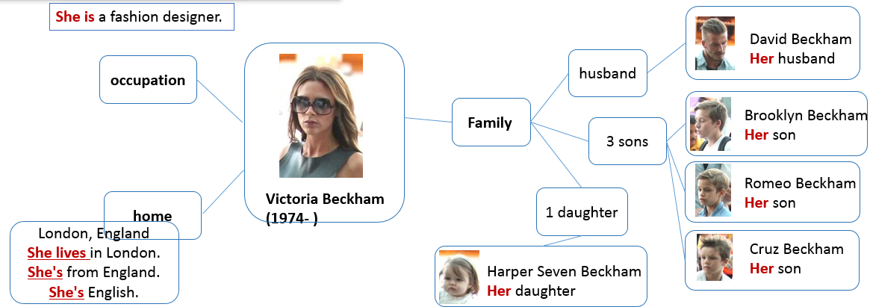

- Draw your family tree.
Please refer to the example of a family tree in Episode 4 Unit 1.

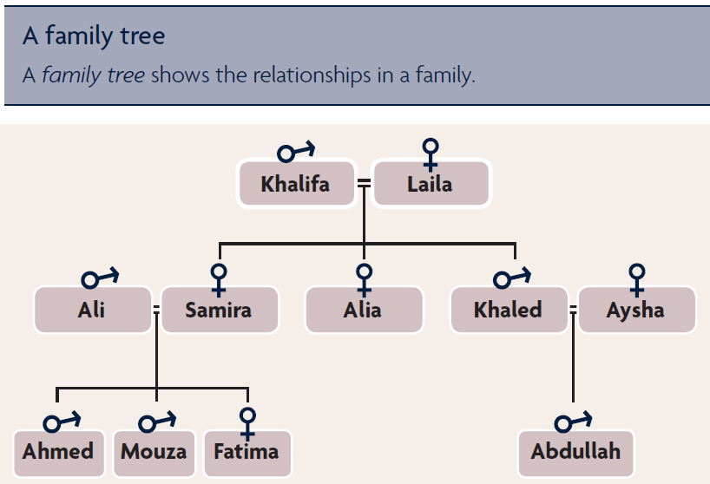

- Speaking task: tell us about the person in your ideas map.
You are recommended to speak it out in the speaking class.

My ideas map is about …

- Writing task: write about somebody in your family.
Please refer to Episode 6 Unit 1 for help.

KEYS

1.
Job | Family
student | father
teacher | sister
doctor | mother
journalist | brother
designer | parents

2. 1) b 2) a 3) b 4) c 5) c

3. 1) is 2) teachers 3) speaks 4) brothers 5) lives 6) Rome

4 – 7 As subjective tasks, there are no suggested answers for them.

Appendix: Worksheet for the speaking class.

以下是听说直播课的部分讲义，建议你提前预习，做好听课准备。

LET’S TALK: Self-introduction
When you listen to other students’ self-introduction, make notes in the chart about them. Then tell us about the classmates that you know.

 | Name | City / Country
Student 1
Student 2
Student 3
Student 4
Student 5
Student 6
Student 7
Student 8

LET’S TALK: Speaking task
1 You are going to tell our group about two people in your family, and listen to other students. Then your group is going to choose the person that you would like to meet.
- Look at the family tree that you have drawn on the worksheet.
- Choose two people and make an ideas map for each person.
- Include information about the person’s occupation, age and parents.

2 Write an introduction for your talk.
Hello! I’m ______ (your name) and I’m from ______ (your city/country).
I’m going to tell you about two family members of mine.

3 Write your talk. Use the information in your ideas map.
______ (name of Person 1) is a ______ (occupation), and ______ (name of Person 2) is a ______ (occupation).
______ (name of Person 1) is ______ (age). His/Her father is ______ (name). He’s a/an ______ (occupation). His/Her mother is ______ (name). She’s a/an ______ (occupation).
______ (name of Person 2) is ______ (age). His/Her father is ______ (name). He’s a/an ______ (occupation). His/Her mother is ______ (name). She’s a/an ______ (occupation).

4. When you listen to other students, make notes in the chart about each person.
 | person 1 | person 2 | person 3 | person 4 | person 5 | person 6
name
occupation
age
family

5. Talk in your group. Which person would you like to meet? Why? Tell the class.

